1 run......

training 1 epoch...

3.111968755722046 seconds used......

1 training finished! average train loss: 2.5097557797151455

total clf loss: 21.70715355873108 total adv loss: 10.479347348213196

evaluating...

Confusion matrix, without normalization

[[ 3 19 19]

[ 3 70 22]

[ 50 273 391]]

Normalized confusion matrix

[[0.07317073 0.46341463 0.46341463]

[0.03157895 0.73684211 0.23157895]

[0.07002801 0.38235294 0.54761905]]

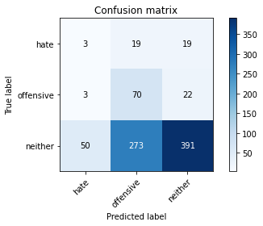

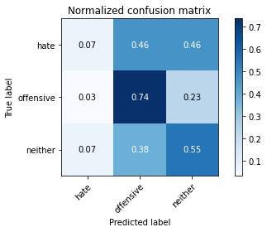

precision recall f1-score support

hate 0.05 0.07 0.06 41

offensive 0.19 0.74 0.31 95

neither 0.91 0.55 0.68 714

accuracy 0.55 850

macro avg 0.38 0.45 0.35 850

weighted avg 0.78 0.55 0.61 850

average eval_loss: 1.0817513951035433, accuracy: 0.5458823529411765

training 2 epoch...

3.2885611057281494 seconds used......

2 training finished! average train loss: 2.191255436224096

total clf loss: 18.103136360645294 total adv loss: 9.57410278916359

evaluating...

Confusion matrix, without normalization

[[ 29 5 7]

[ 59 18 18]

[267 102 345]]

Normalized confusion matrix

[[0.70731707 0.12195122 0.17073171]

[0.62105263 0.18947368 0.18947368]

[0.37394958 0.14285714 0.48319328]]

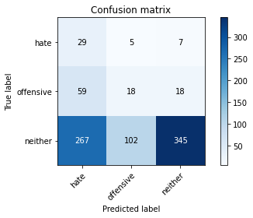

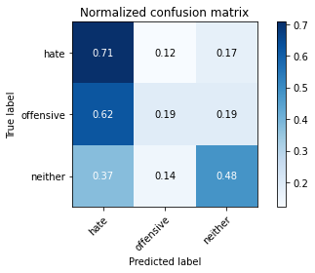

precision recall f1-score support

hate 0.08 0.71 0.15 41

offensive 0.14 0.19 0.16 95

neither 0.93 0.48 0.64 714

accuracy 0.46 850

macro avg 0.39 0.46 0.32 850

weighted avg 0.80 0.46 0.56 850

average eval_loss: 1.0616794186969136, accuracy: 0.4611764705882353

training 3 epoch...

3.121849298477173 seconds used......

3 training finished! average train loss: 2.0178650056614593

total clf loss: 16.49975973367691 total adv loss: 8.901972532272339

evaluating...

Confusion matrix, without normalization

[[ 24 10 7]

[ 36 40 19]

[162 165 387]]

Normalized confusion matrix

[[0.58536585 0.24390244 0.17073171]

[0.37894737 0.42105263 0.2 ]

[0.22689076 0.23109244 0.54201681]]

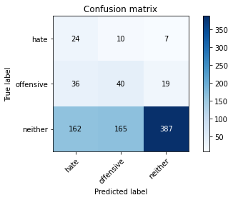

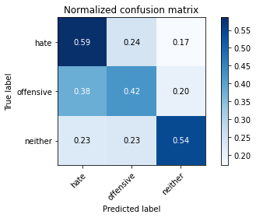

precision recall f1-score support

hate 0.11 0.59 0.18 41

offensive 0.19 0.42 0.26 95

neither 0.94 0.54 0.69 714

accuracy 0.53 850

macro avg 0.41 0.52 0.38 850

weighted avg 0.81 0.53 0.61 850

average eval_loss: 0.979141796744147, accuracy: 0.5305882352941177

training 4 epoch...

3.1451663970947266 seconds used......

4 training finished! average train loss: 1.6411622762680054

total clf loss: 14.268436789512634 total adv loss: 6.815661132335663

evaluating...

Confusion matrix, without normalization

[[ 26 12 3]

[ 34 54 7]

[282 192 240]]

Normalized confusion matrix

[[0.63414634 0.29268293 0.07317073]

[0.35789474 0.56842105 0.07368421]

[0.39495798 0.26890756 0.33613445]]

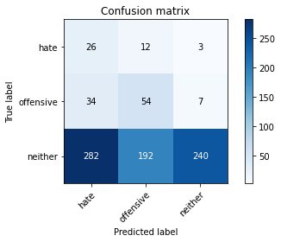

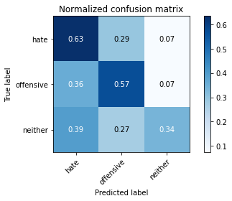

precision recall f1-score support

hate 0.08 0.63 0.14 41

offensive 0.21 0.57 0.31 95

neither 0.96 0.34 0.50 714

accuracy 0.38 850

macro avg 0.42 0.51 0.31 850

weighted avg 0.83 0.38 0.46 850

average eval_loss: 1.0923055382662041, accuracy: 0.3764705882352941

training 5 epoch...

3.103883743286133 seconds used......

5 training finished! average train loss: 1.214856042581446

total clf loss: 11.596396505832672 total adv loss: 4.528078209608793

evaluating...

Confusion matrix, without normalization

[[ 18 14 9]

[ 21 61 13]

[161 158 395]]

Normalized confusion matrix

[[0.43902439 0.34146341 0.2195122 ]

[0.22105263 0.64210526 0.13684211]

[0.2254902 0.22128852 0.55322129]]

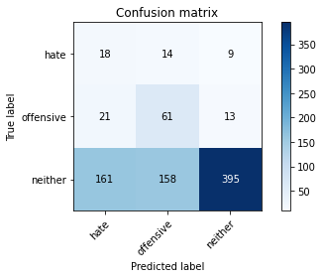

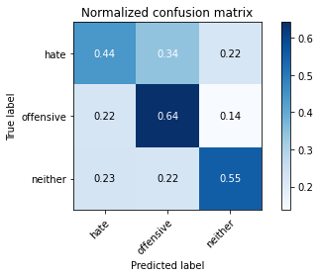

precision recall f1-score support

hate 0.09 0.44 0.15 41

offensive 0.26 0.64 0.37 95

neither 0.95 0.55 0.70 714

accuracy 0.56 850

macro avg 0.43 0.54 0.41 850

weighted avg 0.83 0.56 0.64 850

average eval_loss: 0.9108944115943687, accuracy: 0.5576470588235294

training 6 epoch...

3.1153671741485596 seconds used......

6 training finished! average train loss: 0.7278854163254008

total clf loss: 8.488666832447052 total adv loss: 1.9426926299929619

evaluating...

Confusion matrix, without normalization

[[ 23 13 5]

[ 26 63 6]

[254 178 282]]

Normalized confusion matrix

[[0.56097561 0.31707317 0.12195122]

[0.27368421 0.66315789 0.06315789]

[0.3557423 0.24929972 0.39495798]]

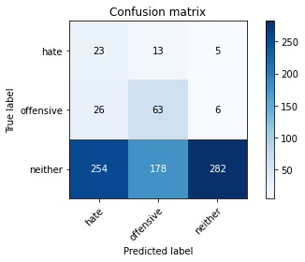

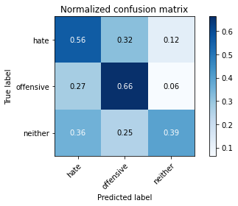

precision recall f1-score support

hate 0.08 0.56 0.13 41

offensive 0.25 0.66 0.36 95

neither 0.96 0.39 0.56 714

accuracy 0.43 850

macro avg 0.43 0.54 0.35 850

weighted avg 0.84 0.43 0.52 850

average eval_loss: 1.1370067634554797, accuracy: 0.4329411764705882

training 7 epoch...

3.0995092391967773 seconds used......

7 training finished! average train loss: 0.3958762200439678

total clf loss: 5.868071809411049 total adv loss: 0.43091197847388685

evaluating...

Confusion matrix, without normalization

[[ 20 12 9]

[ 25 63 7]

[223 180 311]]

Normalized confusion matrix

[[0.48780488 0.29268293 0.2195122 ]

[0.26315789 0.66315789 0.07368421]

[0.31232493 0.25210084 0.43557423]]

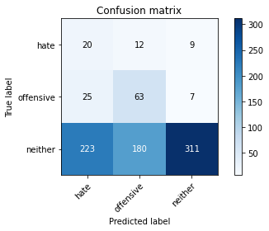

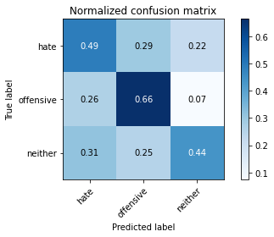

precision recall f1-score support

hate 0.07 0.49 0.13 41

offensive 0.25 0.66 0.36 95

neither 0.95 0.44 0.60 714

accuracy 0.46 850

macro avg 0.42 0.53 0.36 850

weighted avg 0.83 0.46 0.55 850

average eval_loss: 1.1617225394692532, accuracy: 0.46352941176470586

training 8 epoch...

3.1157374382019043 seconds used......

8 training finished! average train loss: 0.2605510520584443

total clf loss: 4.315852031111717 total adv loss: 0.05675792010151781

evaluating...

Confusion matrix, without normalization

[[ 18 16 7]

[ 25 62 8]

[202 212 300]]

Normalized confusion matrix

[[0.43902439 0.3902439 0.17073171]

[0.26315789 0.65263158 0.08421053]

[0.28291317 0.29691877 0.42016807]]

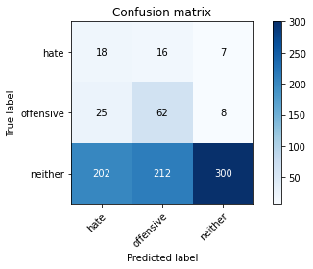

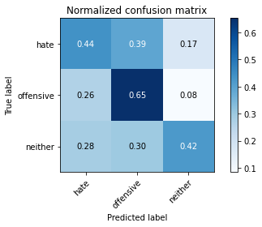

precision recall f1-score support

hate 0.07 0.44 0.13 41

offensive 0.21 0.65 0.32 95

neither 0.95 0.42 0.58 714

accuracy 0.45 850

macro avg 0.41 0.50 0.34 850

weighted avg 0.83 0.45 0.53 850

average eval_loss: 1.3175169686938442, accuracy: 0.4470588235294118

training 9 epoch...

3.14155650138855 seconds used......

9 training finished! average train loss: 0.18326328870128183

total clf loss: 3.0747655481100082 total adv loss: 0.020355164640932344

evaluating...

Confusion matrix, without normalization

[[ 23 7 11]

[ 36 47 12]

[240 110 364]]

Normalized confusion matrix

[[0.56097561 0.17073171 0.26829268]

[0.37894737 0.49473684 0.12631579]

[0.33613445 0.15406162 0.50980392]]

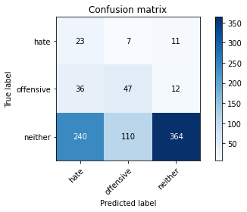

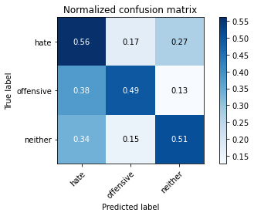

precision recall f1-score support

hate 0.08 0.56 0.14 41

offensive 0.29 0.49 0.36 95

neither 0.94 0.51 0.66 714

accuracy 0.51 850

macro avg 0.43 0.52 0.39 850

weighted avg 0.83 0.51 0.60 850

average eval_loss: 1.1890740217857583, accuracy: 0.5105882352941177

training 10 epoch...

3.1710450649261475 seconds used......

10 training finished! average train loss: 0.13134987718042204

total clf loss: 2.0471187345683575 total adv loss: 0.09291458451480139

evaluating...

Confusion matrix, without normalization

[[ 19 10 12]

[ 34 45 16]

[222 107 385]]

Normalized confusion matrix

[[0.46341463 0.24390244 0.29268293]

[0.35789474 0.47368421 0.16842105]

[0.31092437 0.14985994 0.53921569]]

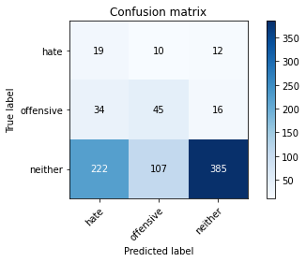

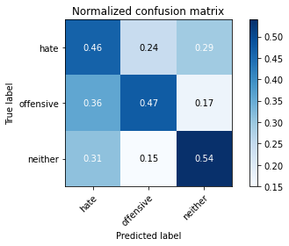

precision recall f1-score support

hate 0.07 0.46 0.12 41

offensive 0.28 0.47 0.35 95

neither 0.93 0.54 0.68 714

accuracy 0.53 850

macro avg 0.43 0.49 0.38 850

weighted avg 0.82 0.53 0.62 850

average eval_loss: 1.2246652162352274, accuracy: 0.528235294117647

2 run......

training 1 epoch...

3.1128768920898438 seconds used......

1 training finished! average train loss: 2.531549341538373

total clf loss: 21.324008345603943 total adv loss: 10.856165140867233

evaluating...

Confusion matrix, without normalization

[[ 15 25 1]

[ 25 66 4]

[215 357 142]]

Normalized confusion matrix

[[0.36585366 0.6097561 0.02439024]

[0.26315789 0.69473684 0.04210526]

[0.30112045 0.5 0.19887955]]

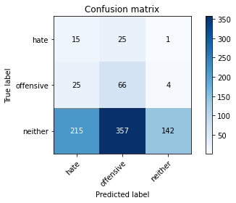

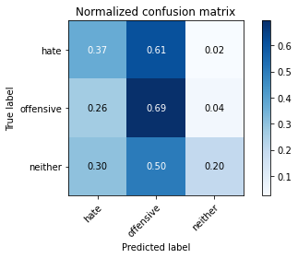

precision recall f1-score support

hate 0.06 0.37 0.10 41

offensive 0.15 0.69 0.24 95

neither 0.97 0.20 0.33 714

accuracy 0.26 850

macro avg 0.39 0.42 0.22 850

weighted avg 0.83 0.26 0.31 850

average eval_loss: 1.2100966004438178, accuracy: 0.26235294117647057

training 2 epoch...

3.22546124458313 seconds used......

2 training finished! average train loss: 2.1753185636856975

total clf loss: 17.848110914230347 total adv loss: 9.566152304410934

evaluating...

Confusion matrix, without normalization

[[ 16 23 2]

[ 27 49 19]

[182 273 259]]

Normalized confusion matrix

[[0.3902439 0.56097561 0.04878049]

[0.28421053 0.51578947 0.2 ]

[0.25490196 0.38235294 0.3627451 ]]

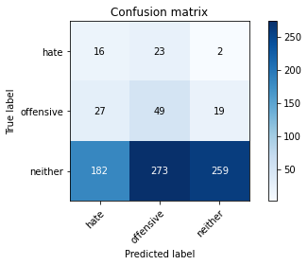

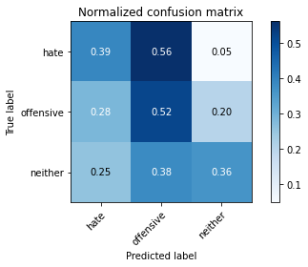

precision recall f1-score support

hate 0.07 0.39 0.12 41

offensive 0.14 0.52 0.22 95

neither 0.93 0.36 0.52 714

accuracy 0.38 850

macro avg 0.38 0.42 0.29 850

weighted avg 0.80 0.38 0.47 850

average eval_loss: 1.1121757598810418, accuracy: 0.3811764705882353

training 3 epoch...

3.1169867515563965 seconds used......

3 training finished! average train loss: 1.863288823296042

total clf loss: 16.017249584197998 total adv loss: 7.829330205917358

evaluating...

Confusion matrix, without normalization

[[ 16 24 1]

[ 29 63 3]

[270 271 173]]

Normalized confusion matrix

[[0.3902439 0.58536585 0.02439024]

[0.30526316 0.66315789 0.03157895]

[0.37815126 0.37955182 0.24229692]]

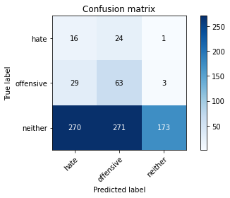

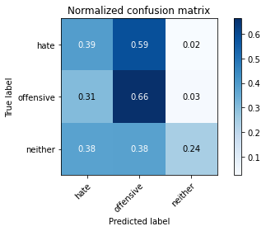

precision recall f1-score support

hate 0.05 0.39 0.09 41

offensive 0.18 0.66 0.28 95

neither 0.98 0.24 0.39 714

accuracy 0.30 850

macro avg 0.40 0.43 0.25 850

weighted avg 0.84 0.30 0.36 850

average eval_loss: 1.156729795558508, accuracy: 0.2964705882352941

training 4 epoch...

3.1412460803985596 seconds used......

4 training finished! average train loss: 1.5161115702460795

total clf loss: 13.854514241218567 total adv loss: 5.959691300988197

evaluating...

Confusion matrix, without normalization

[[ 16 22 3]

[ 22 64 9]

[201 237 276]]

Normalized confusion matrix

[[0.3902439 0.53658537 0.07317073]

[0.23157895 0.67368421 0.09473684]

[0.28151261 0.33193277 0.38655462]]

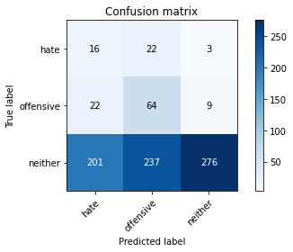

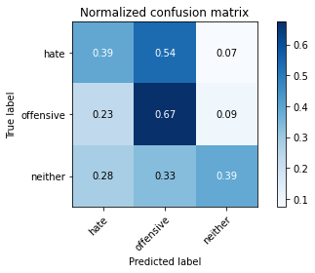

precision recall f1-score support

hate 0.07 0.39 0.11 41

offensive 0.20 0.67 0.31 95

neither 0.96 0.39 0.55 714

accuracy 0.42 850

macro avg 0.41 0.48 0.32 850

weighted avg 0.83 0.42 0.50 850

average eval_loss: 1.038305869282678, accuracy: 0.4188235294117647

training 5 epoch...

3.0955779552459717 seconds used......

5 training finished! average train loss: 1.115782825385823

total clf loss: 11.528390526771545 total adv loss: 3.7199586406350136

evaluating...

Confusion matrix, without normalization

[[ 24 14 3]

[ 32 56 7]

[254 185 275]]

Normalized confusion matrix

[[0.58536585 0.34146341 0.07317073]

[0.33684211 0.58947368 0.07368421]

[0.3557423 0.25910364 0.38515406]]

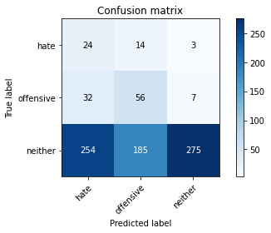

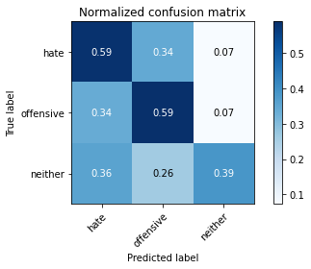

precision recall f1-score support

hate 0.08 0.59 0.14 41

offensive 0.22 0.59 0.32 95

neither 0.96 0.39 0.55 714

accuracy 0.42 850

macro avg 0.42 0.52 0.34 850

weighted avg 0.84 0.42 0.50 850

average eval_loss: 1.039663973935815, accuracy: 0.4176470588235294

training 6 epoch...

3.1256463527679443 seconds used......

6 training finished! average train loss: 0.6858771776451784

total clf loss: 8.856770247220993 total adv loss: 1.4015708798542619

evaluating...

Confusion matrix, without normalization

[[ 30 10 1]

[ 37 51 7]

[286 151 277]]

Normalized confusion matrix

[[0.73170732 0.24390244 0.02439024]

[0.38947368 0.53684211 0.07368421]

[0.40056022 0.21148459 0.38795518]]

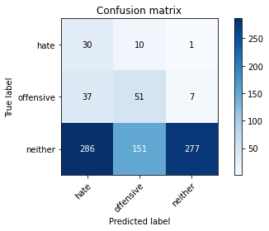

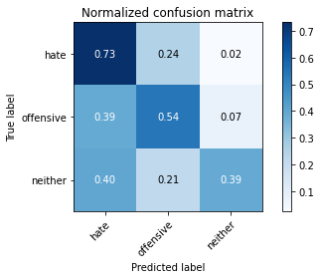

precision recall f1-score support

hate 0.08 0.73 0.15 41

offensive 0.24 0.54 0.33 95

neither 0.97 0.39 0.55 714

accuracy 0.42 850

macro avg 0.43 0.55 0.35 850

weighted avg 0.85 0.42 0.51 850

average eval_loss: 1.0698733475319175, accuracy: 0.4211764705882353

training 7 epoch...

3.103672742843628 seconds used......

7 training finished! average train loss: 0.43142754540723915

total clf loss: 6.681863307952881 total adv loss: 0.3262024305295199

evaluating...

Confusion matrix, without normalization

[[ 19 16 6]

[ 14 58 23]

[108 184 422]]

Normalized confusion matrix

[[0.46341463 0.3902439 0.14634146]

[0.14736842 0.61052632 0.24210526]

[0.1512605 0.25770308 0.59103641]]

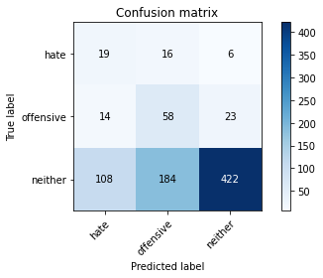

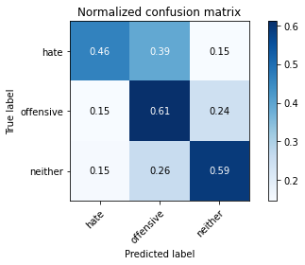

precision recall f1-score support

hate 0.13 0.46 0.21 41

offensive 0.22 0.61 0.33 95

neither 0.94 0.59 0.72 714

accuracy 0.59 850

macro avg 0.43 0.55 0.42 850

weighted avg 0.82 0.59 0.66 850

average eval_loss: 0.9198287406633067, accuracy: 0.5870588235294117

training 8 epoch...

3.117366313934326 seconds used......

8 training finished! average train loss: 0.3179340336252661

total clf loss: 5.105338528752327 total adv loss: 0.14977005717810243

evaluating...

Confusion matrix, without normalization

[[ 23 14 4]

[ 25 56 14]

[197 162 355]]

Normalized confusion matrix

[[0.56097561 0.34146341 0.09756098]

[0.26315789 0.58947368 0.14736842]

[0.27591036 0.22689076 0.49719888]]

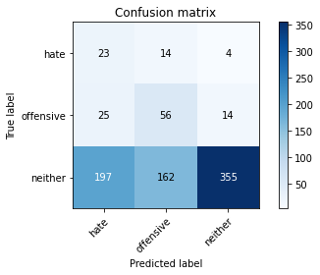

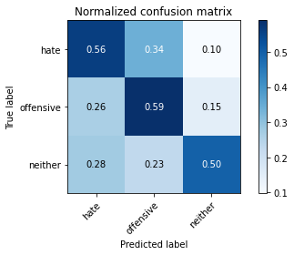

precision recall f1-score support

hate 0.09 0.56 0.16 41

offensive 0.24 0.59 0.34 95

neither 0.95 0.50 0.65 714

accuracy 0.51 850

macro avg 0.43 0.55 0.39 850

weighted avg 0.83 0.51 0.59 850

average eval_loss: 1.0908926195183466, accuracy: 0.5105882352941177

training 9 epoch...

3.1422998905181885 seconds used......

9 training finished! average train loss: 0.2166267116280163

total clf loss: 3.632694900035858 total adv loss: 0.024979595473269

evaluating...

Confusion matrix, without normalization

[[ 28 9 4]

[ 32 49 14]

[234 133 347]]

Normalized confusion matrix

[[0.68292683 0.2195122 0.09756098]

[0.33684211 0.51578947 0.14736842]

[0.32773109 0.18627451 0.4859944 ]]

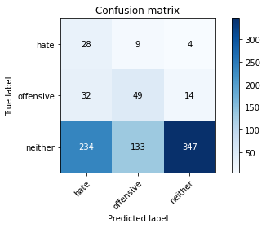

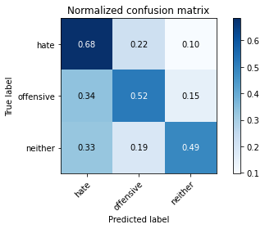

precision recall f1-score support

hate 0.10 0.68 0.17 41

offensive 0.26 0.52 0.34 95

neither 0.95 0.49 0.64 714

accuracy 0.50 850

macro avg 0.43 0.56 0.38 850

weighted avg 0.83 0.50 0.59 850

average eval_loss: 1.166069582104683, accuracy: 0.4988235294117647

training 10 epoch...

3.0925209522247314 seconds used......

10 training finished! average train loss: 0.1486566062359249

total clf loss: 2.47645503282547 total adv loss: 0.025353644668939523

evaluating...

Confusion matrix, without normalization

[[ 24 15 2]

[ 25 59 11]

[210 174 330]]

Normalized confusion matrix

[[0.58536585 0.36585366 0.04878049]

[0.26315789 0.62105263 0.11578947]

[0.29411765 0.24369748 0.46218487]]

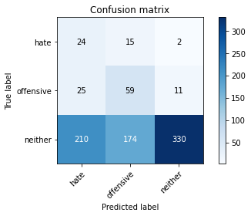

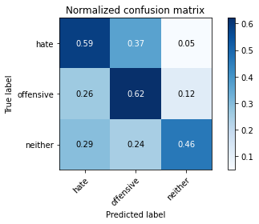

precision recall f1-score support

hate 0.09 0.59 0.16 41

offensive 0.24 0.62 0.34 95

neither 0.96 0.46 0.62 714

accuracy 0.49 850

macro avg 0.43 0.56 0.38 850

weighted avg 0.84 0.49 0.57 850

average eval_loss: 1.3461279964377715, accuracy: 0.4858823529411765

3 run......

training 1 epoch...

3.1254963874816895 seconds used......

1 training finished! average train loss: 2.5147588954252353

total clf loss: 21.402344465255737 total adv loss: 10.674278318881989

evaluating...

Confusion matrix, without normalization

[[ 20 16 5]

[ 10 39 46]

[163 214 337]]

Normalized confusion matrix

[[0.48780488 0.3902439 0.12195122]

[0.10526316 0.41052632 0.48421053]

[0.22829132 0.29971989 0.4719888 ]]

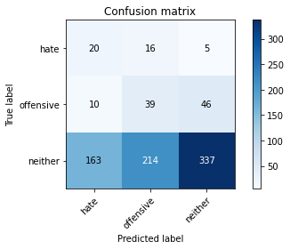

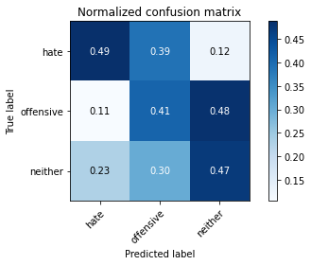

precision recall f1-score support

hate 0.10 0.49 0.17 41

offensive 0.14 0.41 0.21 95

neither 0.87 0.47 0.61 714

accuracy 0.47 850

macro avg 0.37 0.46 0.33 850

weighted avg 0.75 0.47 0.55 850

average eval_loss: 1.1130816797877467, accuracy: 0.46588235294117647

training 2 epoch...

3.1846187114715576 seconds used......

2 training finished! average train loss: 2.279405067948734

total clf loss: 18.275672554969788 total adv loss: 10.23710685968399

evaluating...

Confusion matrix, without normalization

[[ 18 22 1]

[ 28 61 6]

[248 317 149]]

Normalized confusion matrix

[[0.43902439 0.53658537 0.02439024]

[0.29473684 0.64210526 0.06315789]

[0.34733894 0.44397759 0.20868347]]

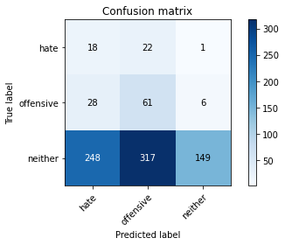

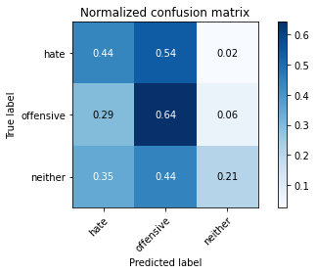

precision recall f1-score support

hate 0.06 0.44 0.11 41

offensive 0.15 0.64 0.25 95

neither 0.96 0.21 0.34 714

accuracy 0.27 850

macro avg 0.39 0.43 0.23 850

weighted avg 0.82 0.27 0.32 850

average eval_loss: 1.2367453727611275, accuracy: 0.26823529411764707

training 3 epoch...

3.103027105331421 seconds used......

3 training finished! average train loss: 2.1212898633059334

total clf loss: 17.07131540775299 total adv loss: 9.495306298136711

evaluating...

Confusion matrix, without normalization

[[ 18 22 1]

[ 24 58 13]

[198 251 265]]

Normalized confusion matrix

[[0.43902439 0.53658537 0.02439024]

[0.25263158 0.61052632 0.13684211]

[0.27731092 0.35154062 0.37114846]]

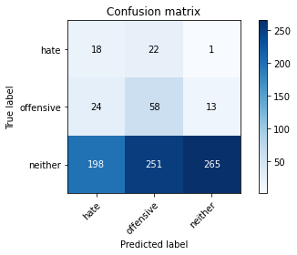

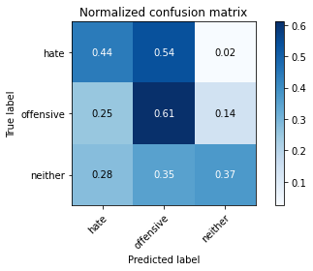

precision recall f1-score support

hate 0.07 0.44 0.13 41

offensive 0.18 0.61 0.27 95

neither 0.95 0.37 0.53 714

accuracy 0.40 850

macro avg 0.40 0.47 0.31 850

weighted avg 0.82 0.40 0.48 850

average eval_loss: 1.1312072942423266, accuracy: 0.4011764705882353

training 4 epoch...

3.155700922012329 seconds used......

4 training finished! average train loss: 1.8320997953414917

total clf loss: 15.680744051933289 total adv loss: 7.732476204633713

evaluating...

Confusion matrix, without normalization

[[ 26 14 1]

[ 38 46 11]

[297 173 244]]

Normalized confusion matrix

[[0.63414634 0.34146341 0.02439024]

[0.4 0.48421053 0.11578947]

[0.41596639 0.24229692 0.34173669]]

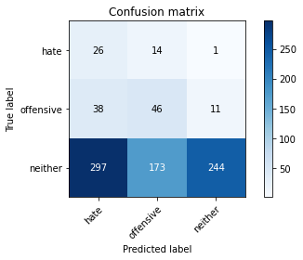

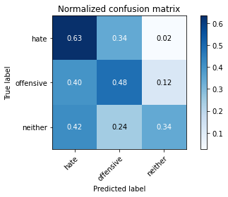

precision recall f1-score support

hate 0.07 0.63 0.13 41

offensive 0.20 0.48 0.28 95

neither 0.95 0.34 0.50 714

accuracy 0.37 850

macro avg 0.41 0.49 0.30 850

weighted avg 0.83 0.37 0.46 850

average eval_loss: 1.1417116203973459, accuracy: 0.37176470588235294

training 5 epoch...

3.0991077423095703 seconds used......

5 training finished! average train loss: 1.4586741433424109

total clf loss: 13.2934730052948 total adv loss: 5.751993715763092

evaluating...

Confusion matrix, without normalization

[[ 21 19 1]

[ 22 62 11]

[251 223 240]]

Normalized confusion matrix

[[0.51219512 0.46341463 0.02439024]

[0.23157895 0.65263158 0.11578947]

[0.35154062 0.31232493 0.33613445]]

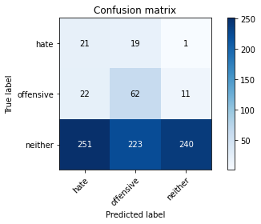

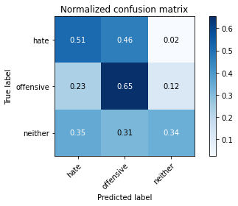

precision recall f1-score support

hate 0.07 0.51 0.13 41

offensive 0.20 0.65 0.31 95

neither 0.95 0.34 0.50 714

accuracy 0.38 850

macro avg 0.41 0.50 0.31 850

weighted avg 0.83 0.38 0.46 850

average eval_loss: 1.1678724108740342, accuracy: 0.38

training 6 epoch...

3.0969972610473633 seconds used......

6 training finished! average train loss: 1.1225264563279993

total clf loss: 11.076838105916977 total adv loss: 4.003055647015572

evaluating...

Confusion matrix, without normalization

[[ 19 21 1]

[ 22 69 4]

[267 258 189]]

Normalized confusion matrix

[[0.46341463 0.51219512 0.02439024]

[0.23157895 0.72631579 0.04210526]

[0.37394958 0.36134454 0.26470588]]

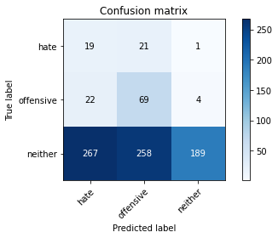

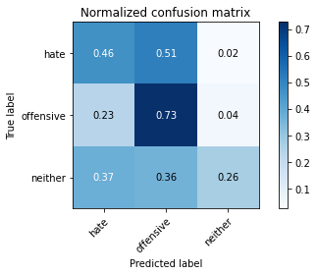

precision recall f1-score support

hate 0.06 0.46 0.11 41

offensive 0.20 0.73 0.31 95

neither 0.97 0.26 0.42 714

accuracy 0.33 850

macro avg 0.41 0.48 0.28 850

weighted avg 0.84 0.33 0.39 850

average eval_loss: 1.3128688973049785, accuracy: 0.32588235294117646

training 7 epoch...

3.165217876434326 seconds used......

7 training finished! average train loss: 0.6870672965750975

total clf loss: 8.452123671770096 total adv loss: 1.6140101868659258

evaluating...

Confusion matrix, without normalization

[[ 25 14 2]

[ 19 59 17]

[195 166 353]]

Normalized confusion matrix

[[0.6097561 0.34146341 0.04878049]

[0.2 0.62105263 0.17894737]

[0.27310924 0.232493 0.49439776]]

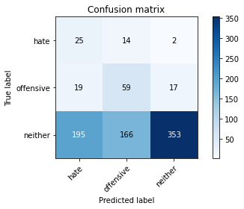

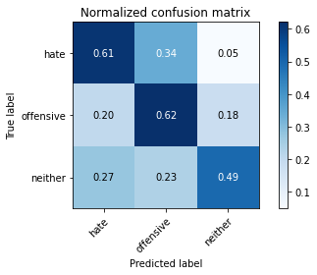

precision recall f1-score support

hate 0.10 0.61 0.18 41

offensive 0.25 0.62 0.35 95

neither 0.95 0.49 0.65 714

accuracy 0.51 850

macro avg 0.43 0.58 0.39 850

weighted avg 0.83 0.51 0.59 850

average eval_loss: 1.019086544250333, accuracy: 0.5141176470588236

training 8 epoch...

3.1100432872772217 seconds used......

8 training finished! average train loss: 0.3963187073960024

total clf loss: 6.306762367486954 total adv loss: 0.2153278369223699

evaluating...

Confusion matrix, without normalization

[[ 21 17 3]

[ 21 60 14]

[213 174 327]]

Normalized confusion matrix

[[0.51219512 0.41463415 0.07317073]

[0.22105263 0.63157895 0.14736842]

[0.29831933 0.24369748 0.45798319]]

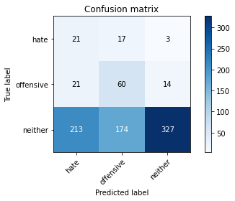

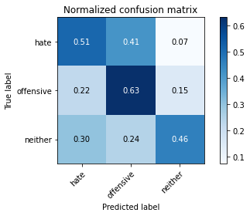

precision recall f1-score support

hate 0.08 0.51 0.14 41

offensive 0.24 0.63 0.35 95

neither 0.95 0.46 0.62 714

accuracy 0.48 850

macro avg 0.42 0.53 0.37 850

weighted avg 0.83 0.48 0.56 850

average eval_loss: 1.0912773726984513, accuracy: 0.48

training 9 epoch...

3.144585132598877 seconds used......

9 training finished! average train loss: 0.2736157643444398

total clf loss: 4.6130398362874985 total adv loss: 0.019214078463846818

evaluating...

Confusion matrix, without normalization

[[ 18 17 6]

[ 17 55 23]

[142 146 426]]

Normalized confusion matrix

[[0.43902439 0.41463415 0.14634146]

[0.17894737 0.57894737 0.24210526]

[0.19887955 0.20448179 0.59663866]]

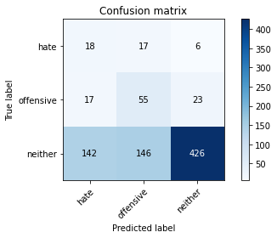

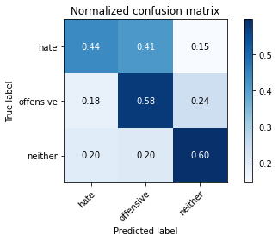

precision recall f1-score support

hate 0.10 0.44 0.17 41

offensive 0.25 0.58 0.35 95

neither 0.94 0.60 0.73 714

accuracy 0.59 850

macro avg 0.43 0.54 0.42 850

weighted avg 0.82 0.59 0.66 850

average eval_loss: 0.9667070435230122, accuracy: 0.5870588235294117

training 10 epoch...

3.1136412620544434 seconds used......

10 training finished! average train loss: 0.23627942756694906

total clf loss: 3.9898843988776207 total adv loss: 0.013432937041216064

evaluating...

Confusion matrix, without normalization

[[ 21 15 5]

[ 24 55 16]

[224 143 347]]

Normalized confusion matrix

[[0.51219512 0.36585366 0.12195122]

[0.25263158 0.57894737 0.16842105]

[0.31372549 0.20028011 0.4859944 ]]

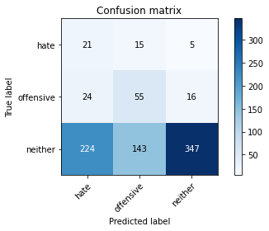

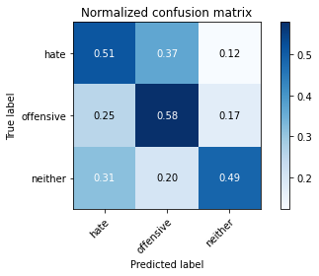

precision recall f1-score support

hate 0.08 0.51 0.14 41

offensive 0.26 0.58 0.36 95

neither 0.94 0.49 0.64 714

accuracy 0.50 850

macro avg 0.43 0.53 0.38 850

weighted avg 0.82 0.50 0.59 850

average eval_loss: 1.167139101600231, accuracy: 0.4976470588235294

4 run......

training 1 epoch...

3.127976655960083 seconds used......

1 training finished! average train loss: 2.5345710165360393

total clf loss: 20.32730746269226 total adv loss: 11.380199790000916

evaluating...

Confusion matrix, without normalization

[[ 25 10 6]

[ 71 6 18]

[297 154 263]]

Normalized confusion matrix

[[0.6097561 0.24390244 0.14634146]

[0.74736842 0.06315789 0.18947368]

[0.41596639 0.21568627 0.36834734]]

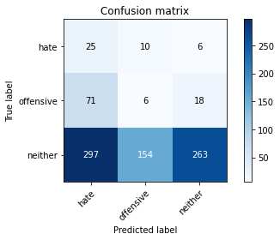

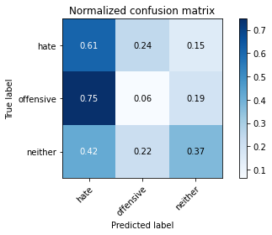

precision recall f1-score support

hate 0.06 0.61 0.12 41

offensive 0.04 0.06 0.05 95

neither 0.92 0.37 0.53 714

accuracy 0.35 850

macro avg 0.34 0.35 0.23 850

weighted avg 0.78 0.35 0.45 850

average eval_loss: 1.1160059044527453, accuracy: 0.3458823529411765

training 2 epoch...

3.1472246646881104 seconds used......

2 training finished! average train loss: 2.270129084587097

total clf loss: 17.95738995075226 total adv loss: 10.317402422428131

evaluating...

Confusion matrix, without normalization

[[ 13 27 1]

[ 59 33 3]

[248 314 152]]

Normalized confusion matrix

[[0.31707317 0.65853659 0.02439024]

[0.62105263 0.34736842 0.03157895]

[0.34733894 0.43977591 0.21288515]]

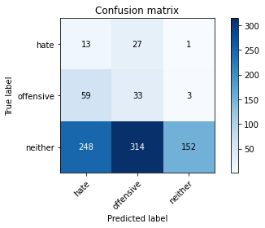

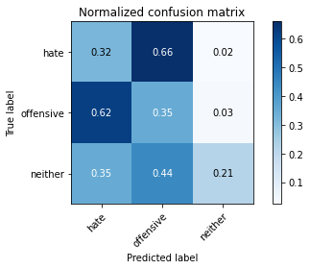

precision recall f1-score support

hate 0.04 0.32 0.07 41

offensive 0.09 0.35 0.14 95

neither 0.97 0.21 0.35 714

accuracy 0.23 850

macro avg 0.37 0.29 0.19 850

weighted avg 0.83 0.23 0.31 850

average eval_loss: 1.1999875390252401, accuracy: 0.23294117647058823

training 3 epoch...

3.1117827892303467 seconds used......

3 training finished! average train loss: 1.9867210808922262

total clf loss: 16.428202629089355 total adv loss: 8.6730278134346

evaluating...

Confusion matrix, without normalization

[[ 21 19 1]

[ 61 30 4]

[289 230 195]]

Normalized confusion matrix

[[0.51219512 0.46341463 0.02439024]

[0.64210526 0.31578947 0.04210526]

[0.4047619 0.32212885 0.27310924]]

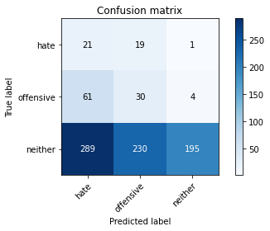

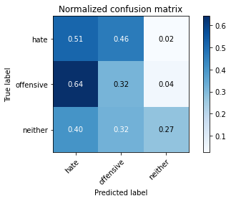

precision recall f1-score support

hate 0.06 0.51 0.10 41

offensive 0.11 0.32 0.16 95

neither 0.97 0.27 0.43 714

accuracy 0.29 850

macro avg 0.38 0.37 0.23 850

weighted avg 0.83 0.29 0.38 850

average eval_loss: 1.1299965603407038, accuracy: 0.28941176470588237

training 4 epoch...

3.1208243370056152 seconds used......

4 training finished! average train loss: 1.6628313134698307

total clf loss: 14.163936793804169 total adv loss: 7.0520977303385735

evaluating...

Confusion matrix, without normalization

[[ 20 19 2]

[ 31 60 4]

[240 270 204]]

Normalized confusion matrix

[[0.48780488 0.46341463 0.04878049]

[0.32631579 0.63157895 0.04210526]

[0.33613445 0.37815126 0.28571429]]

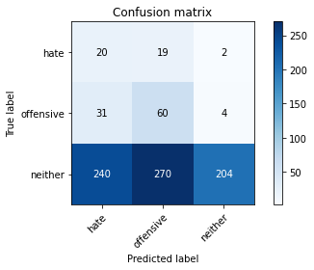

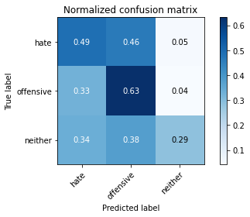

precision recall f1-score support

hate 0.07 0.49 0.12 41

offensive 0.17 0.63 0.27 95

neither 0.97 0.29 0.44 714

accuracy 0.33 850

macro avg 0.40 0.47 0.28 850

weighted avg 0.84 0.33 0.41 850

average eval_loss: 1.1291352198567501, accuracy: 0.3341176470588235

training 5 epoch...

3.100306510925293 seconds used......

5 training finished! average train loss: 1.2132277348462273

total clf loss: 11.41471016407013 total adv loss: 4.605080746114254

evaluating...

Confusion matrix, without normalization

[[ 26 13 2]

[ 35 52 8]

[262 189 263]]

Normalized confusion matrix

[[0.63414634 0.31707317 0.04878049]

[0.36842105 0.54736842 0.08421053]

[0.36694678 0.26470588 0.36834734]]

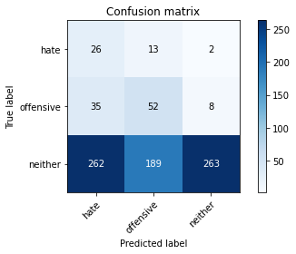

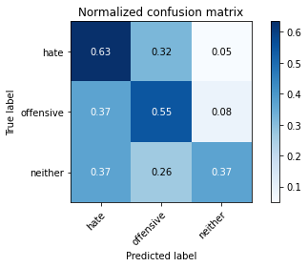

precision recall f1-score support

hate 0.08 0.63 0.14 41

offensive 0.20 0.55 0.30 95

neither 0.96 0.37 0.53 714

accuracy 0.40 850

macro avg 0.42 0.52 0.32 850

weighted avg 0.84 0.40 0.49 850

average eval_loss: 1.060252048595007, accuracy: 0.4011764705882353

training 6 epoch...

3.1193253993988037 seconds used......

6 training finished! average train loss: 0.8604411938611198

total clf loss: 8.87575450539589 total adv loss: 2.8758729360997677

evaluating...

Confusion matrix, without normalization

[[ 21 17 3]

[ 26 62 7]

[236 237 241]]

Normalized confusion matrix

[[0.51219512 0.41463415 0.07317073]

[0.27368421 0.65263158 0.07368421]

[0.33053221 0.33193277 0.33753501]]

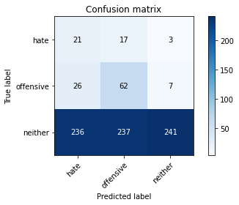

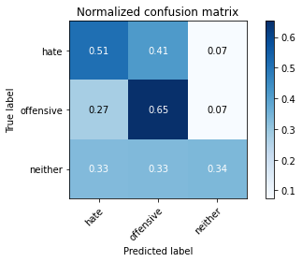

precision recall f1-score support

hate 0.07 0.51 0.13 41

offensive 0.20 0.65 0.30 95

neither 0.96 0.34 0.50 714

accuracy 0.38 850

macro avg 0.41 0.50 0.31 850

weighted avg 0.83 0.38 0.46 850

average eval_loss: 1.1845257883501608, accuracy: 0.3811764705882353

training 7 epoch...

3.1480891704559326 seconds used......

7 training finished! average train loss: 0.5202793706865871

total clf loss: 6.459343492984772 total adv loss: 1.192702884785831

evaluating...

Confusion matrix, without normalization

[[ 15 21 5]

[ 19 68 8]

[171 258 285]]

Normalized confusion matrix

[[0.36585366 0.51219512 0.12195122]

[0.2 0.71578947 0.08421053]

[0.2394958 0.36134454 0.39915966]]

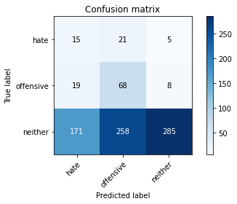

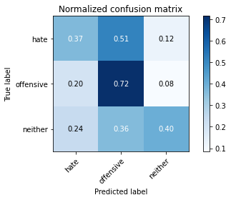

precision recall f1-score support

hate 0.07 0.37 0.12 41

offensive 0.20 0.72 0.31 95

neither 0.96 0.40 0.56 714

accuracy 0.43 850

macro avg 0.41 0.49 0.33 850

weighted avg 0.83 0.43 0.51 850

average eval_loss: 1.1859037846673366, accuracy: 0.4329411764705882

training 8 epoch...

3.1057868003845215 seconds used......

8 training finished! average train loss: 0.2978563904762268

total clf loss: 4.6105198711156845 total adv loss: 0.22651940176729113

evaluating...

Confusion matrix, without normalization

[[ 15 20 6]

[ 17 67 11]

[142 237 335]]

Normalized confusion matrix

[[0.36585366 0.48780488 0.14634146]

[0.17894737 0.70526316 0.11578947]

[0.19887955 0.33193277 0.46918768]]

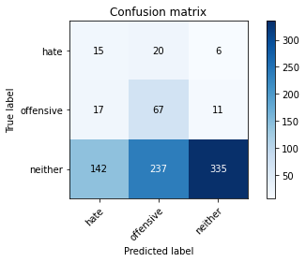

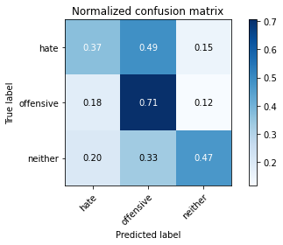

precision recall f1-score support

hate 0.09 0.37 0.14 41

offensive 0.21 0.71 0.32 95

neither 0.95 0.47 0.63 714

accuracy 0.49 850

macro avg 0.41 0.51 0.36 850

weighted avg 0.83 0.49 0.57 850

average eval_loss: 1.1472524746732657, accuracy: 0.49058823529411766

training 9 epoch...

3.141920566558838 seconds used......

9 training finished! average train loss: 0.1804687358877238

total clf loss: 3.0226012095808983 total adv loss: 0.022683653733110987

evaluating...

Confusion matrix, without normalization

[[ 17 12 12]

[ 19 57 19]

[151 173 390]]

Normalized confusion matrix

[[0.41463415 0.29268293 0.29268293]

[0.2 0.6 0.2 ]

[0.21148459 0.24229692 0.54621849]]

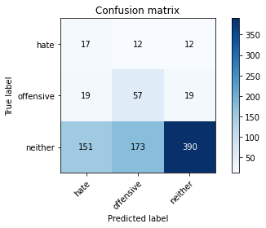

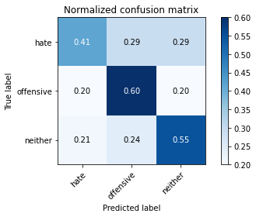

precision recall f1-score support

hate 0.09 0.41 0.15 41

offensive 0.24 0.60 0.34 95

neither 0.93 0.55 0.69 714

accuracy 0.55 850

macro avg 0.42 0.52 0.39 850

weighted avg 0.81 0.55 0.62 850

average eval_loss: 1.0512577591593875, accuracy: 0.5458823529411765

training 10 epoch...

3.118875741958618 seconds used......

10 training finished! average train loss: 0.10422143778380226

total clf loss: 1.7542676031589508 total adv loss: 0.00874841574113816

evaluating...

Confusion matrix, without normalization

[[ 15 15 11]

[ 17 61 17]

[132 194 388]]

Normalized confusion matrix

[[0.36585366 0.36585366 0.26829268]

[0.17894737 0.64210526 0.17894737]

[0.18487395 0.27170868 0.54341737]]

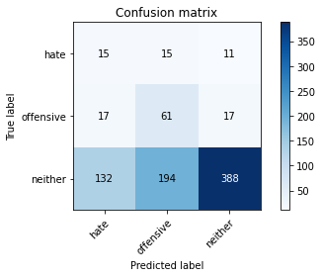

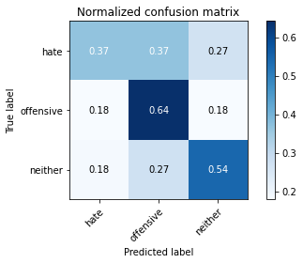

precision recall f1-score support

hate 0.09 0.37 0.15 41

offensive 0.23 0.64 0.33 95

neither 0.93 0.54 0.69 714

accuracy 0.55 850

macro avg 0.42 0.52 0.39 850

weighted avg 0.81 0.55 0.62 850

average eval_loss: 1.1385989377578332, accuracy: 0.5458823529411765

5 run......

training 1 epoch...

3.2173097133636475 seconds used......

1 training finished! average train loss: 2.550505049088422

total clf loss: 20.59506916999817 total adv loss: 11.381758451461792

evaluating...

Confusion matrix, without normalization

[[ 3 37 1]

[ 9 69 17]

[100 368 246]]

Normalized confusion matrix

[[0.07317073 0.90243902 0.02439024]

[0.09473684 0.72631579 0.17894737]

[0.14005602 0.51540616 0.34453782]]

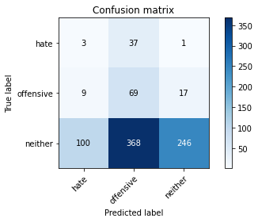

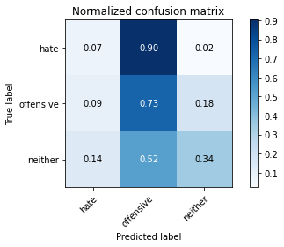

precision recall f1-score support

hate 0.03 0.07 0.04 41

offensive 0.15 0.73 0.24 95

neither 0.93 0.34 0.50 714

accuracy 0.37 850

macro avg 0.37 0.38 0.26 850

weighted avg 0.80 0.37 0.45 850

average eval_loss: 1.1479635793109273, accuracy: 0.37411764705882355

training 2 epoch...

3.1242012977600098 seconds used......

2 training finished! average train loss: 2.2445177400813385

total clf loss: 17.763560950756073 total adv loss: 10.196620374917984

evaluating...

Confusion matrix, without normalization

[[ 20 20 1]

[ 71 16 8]

[322 178 214]]

Normalized confusion matrix

[[0.48780488 0.48780488 0.02439024]

[0.74736842 0.16842105 0.08421053]

[0.45098039 0.24929972 0.29971989]]

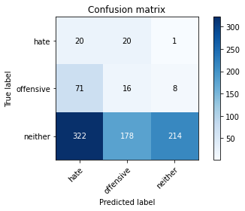

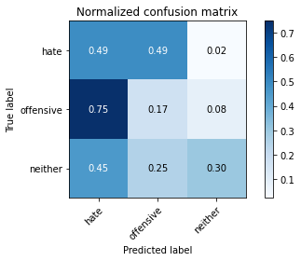

precision recall f1-score support

hate 0.05 0.49 0.09 41

offensive 0.07 0.17 0.10 95

neither 0.96 0.30 0.46 714

accuracy 0.29 850

macro avg 0.36 0.32 0.22 850

weighted avg 0.82 0.29 0.40 850

average eval_loss: 1.1459389689356783, accuracy: 0.29411764705882354

training 3 epoch...

3.124753713607788 seconds used......

3 training finished! average train loss: 2.0219868772170124

total clf loss: 16.141284108161926 total adv loss: 9.11624625325203

evaluating...

Confusion matrix, without normalization

[[ 9 31 1]

[ 18 73 4]

[168 352 194]]

Normalized confusion matrix

[[0.2195122 0.75609756 0.02439024]

[0.18947368 0.76842105 0.04210526]

[0.23529412 0.4929972 0.27170868]]

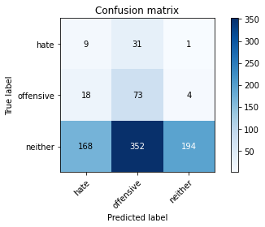

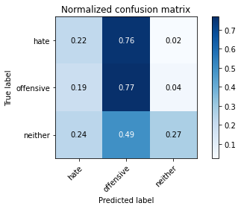

precision recall f1-score support

hate 0.05 0.22 0.08 41

offensive 0.16 0.77 0.26 95

neither 0.97 0.27 0.42 714

accuracy 0.32 850

macro avg 0.39 0.42 0.26 850

weighted avg 0.84 0.32 0.39 850

average eval_loss: 1.1852601614109306, accuracy: 0.3247058823529412

training 4 epoch...

3.0886054039001465 seconds used......

4 training finished! average train loss: 1.8094599878086763

total clf loss: 14.284600257873535 total adv loss: 8.238109797239304

evaluating...

Confusion matrix, without normalization

[[ 15 25 1]

[ 19 66 10]

[206 263 245]]

Normalized confusion matrix

[[0.36585366 0.6097561 0.02439024]

[0.2 0.69473684 0.10526316]

[0.28851541 0.36834734 0.34313725]]

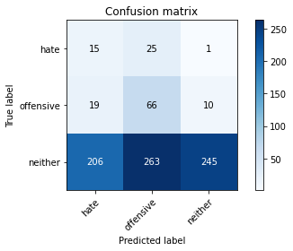

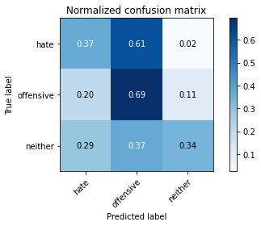

precision recall f1-score support

hate 0.06 0.37 0.11 41

offensive 0.19 0.69 0.29 95

neither 0.96 0.34 0.51 714

accuracy 0.38 850

macro avg 0.40 0.47 0.30 850

weighted avg 0.83 0.38 0.46 850

average eval_loss: 1.10991901540479, accuracy: 0.3835294117647059

training 5 epoch...

3.113811731338501 seconds used......

5 training finished! average train loss: 1.3402632124283735

total clf loss: 11.908778429031372 total adv loss: 5.437847912311554

evaluating...

Confusion matrix, without normalization

[[ 33 7 1]

[ 39 53 3]

[374 188 152]]

Normalized confusion matrix

[[0.80487805 0.17073171 0.02439024]

[0.41052632 0.55789474 0.03157895]

[0.52380952 0.26330532 0.21288515]]

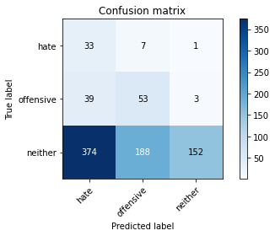

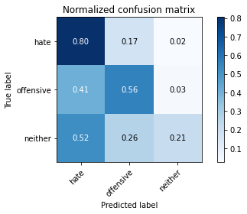

precision recall f1-score support

hate 0.07 0.80 0.14 41

offensive 0.21 0.56 0.31 95

neither 0.97 0.21 0.35 714

accuracy 0.28 850

macro avg 0.42 0.53 0.26 850

weighted avg 0.85 0.28 0.33 850

average eval_loss: 1.4392095935899158, accuracy: 0.28

training 6 epoch...

3.190822124481201 seconds used......

6 training finished! average train loss: 0.8581993001348832

total clf loss: 8.656694740056992 total adv loss: 2.9663467071950436

evaluating...

Confusion matrix, without normalization

[[ 23 16 2]

[ 18 64 13]

[215 201 298]]

Normalized confusion matrix

[[0.56097561 0.3902439 0.04878049]

[0.18947368 0.67368421 0.13684211]

[0.30112045 0.28151261 0.41736695]]

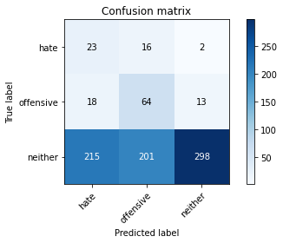

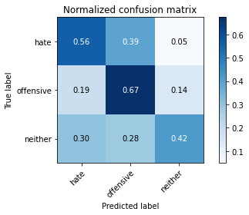

precision recall f1-score support

hate 0.09 0.56 0.15 41

offensive 0.23 0.67 0.34 95

neither 0.95 0.42 0.58 714

accuracy 0.45 850

macro avg 0.42 0.55 0.36 850

weighted avg 0.83 0.45 0.53 850

average eval_loss: 1.081601120011751, accuracy: 0.45294117647058824

training 7 epoch...

3.1386406421661377 seconds used......

7 training finished! average train loss: 0.4923221889664145

total clf loss: 6.177000850439072 total adv loss: 1.0962381474673748

evaluating...

Confusion matrix, without normalization

[[ 27 7 7]

[ 22 56 17]

[211 149 354]]

Normalized confusion matrix

[[0.65853659 0.17073171 0.17073171]

[0.23157895 0.58947368 0.17894737]

[0.29551821 0.20868347 0.49579832]]

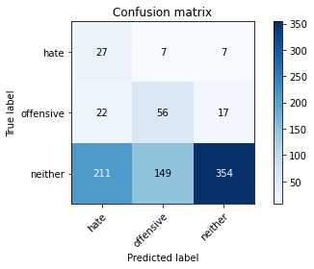

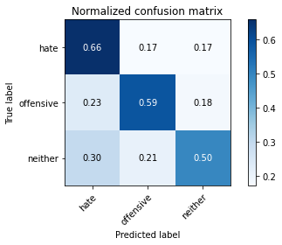

precision recall f1-score support

hate 0.10 0.66 0.18 41

offensive 0.26 0.59 0.36 95

neither 0.94 0.50 0.65 714

accuracy 0.51 850

macro avg 0.43 0.58 0.40 850

weighted avg 0.82 0.51 0.59 850

average eval_loss: 0.9899338286283405, accuracy: 0.5141176470588236

training 8 epoch...

3.1010427474975586 seconds used......

8 training finished! average train loss: 0.27884499728679657

total clf loss: 4.111022815108299 total adv loss: 0.3146710707806051

evaluating...

Confusion matrix, without normalization

[[ 23 12 6]

[ 25 61 9]

[249 178 287]]

Normalized confusion matrix

[[0.56097561 0.29268293 0.14634146]

[0.26315789 0.64210526 0.09473684]

[0.3487395 0.24929972 0.40196078]]

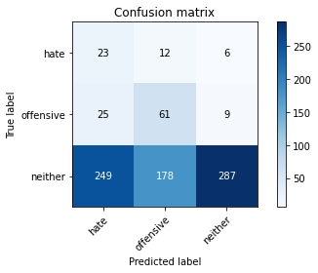

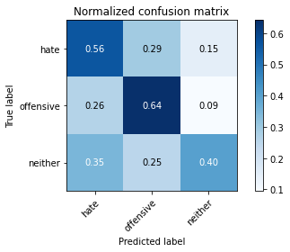

precision recall f1-score support

hate 0.08 0.56 0.14 41

offensive 0.24 0.64 0.35 95

neither 0.95 0.40 0.56 714

accuracy 0.44 850

macro avg 0.42 0.54 0.35 850

weighted avg 0.83 0.44 0.52 850

average eval_loss: 1.2834289067013318, accuracy: 0.4364705882352941

training 9 epoch...

3.1516034603118896 seconds used......

9 training finished! average train loss: 0.19470232549835653

total clf loss: 3.040560320019722 total adv loss: 0.13468962954357266

evaluating...

Confusion matrix, without normalization

[[ 16 10 15]

[ 19 53 23]

[162 136 416]]

Normalized confusion matrix

[[0.3902439 0.24390244 0.36585366]

[0.2 0.55789474 0.24210526]

[0.22689076 0.19047619 0.58263305]]

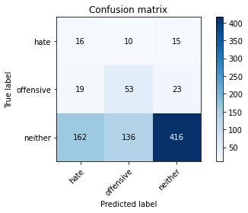

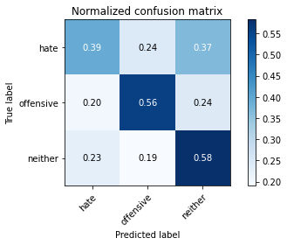

precision recall f1-score support

hate 0.08 0.39 0.13 41

offensive 0.27 0.56 0.36 95

neither 0.92 0.58 0.71 714

accuracy 0.57 850

macro avg 0.42 0.51 0.40 850

weighted avg 0.80 0.57 0.65 850

average eval_loss: 0.9613022164896478, accuracy: 0.5705882352941176

training 10 epoch...

3.0986478328704834 seconds used......

10 training finished! average train loss: 0.12129483437713455

total clf loss: 2.033245325088501 total adv loss: 0.014383426336280536

evaluating...

Confusion matrix, without normalization

[[ 16 14 11]

[ 20 63 12]

[180 175 359]]

Normalized confusion matrix

[[0.3902439 0.34146341 0.26829268]

[0.21052632 0.66315789 0.12631579]

[0.25210084 0.24509804 0.50280112]]

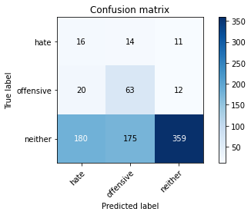

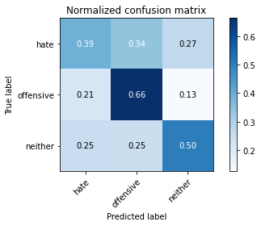

precision recall f1-score support

hate 0.07 0.39 0.12 41

offensive 0.25 0.66 0.36 95

neither 0.94 0.50 0.66 714

accuracy 0.52 850

macro avg 0.42 0.52 0.38 850

weighted avg 0.82 0.52 0.60 850

average eval_loss: 1.2345650655239127, accuracy: 0.5152941176470588